English homework ch.14 part 1
We have read about Christopher Columbus this week. He was an explorer who went to America. If you were an explorer 500 years ago, where would you have travelled?
Write down:
- Where (country/continent)?
- How (what kind of boat)?
- Who travel with you(friends, family, classmates)?
- What will you do when you get to your country/continent)?
- How long will you stay there?

Prepare to tell me and your friends about your trip

English homework ch.14 part 1
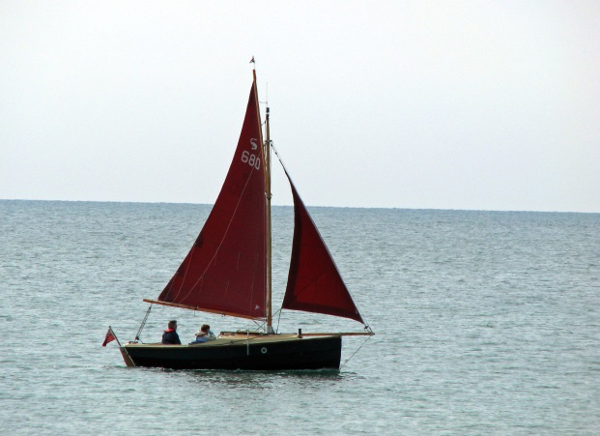
We have read about Christopher Columbus this week. He was an explorer who went to America. If you were an explorer 500 years ago, where would you have travelled?
Write down:
- Where (country/continent)?
- How (what kind of boat)?
- Who travel with you(friends, family, classmates)?
- What will you do when you get to your country/continent)?
- How long will you stay there?

Prepare to tell me and your friends about your trip

